OBJECT ORIENTED ANALYSIS AND DESIGN IN

INDUSTRIAL PERSPECTIVE

SLOT-D LAB PRACTICALS DAY-3

21. Develop a system using UML for Hospital Management System. The central system should manage patients’ and doctors’ appointments and case details. Also, include medical prescriptions and consultation fee details.

**CLASS DIAGRAM**

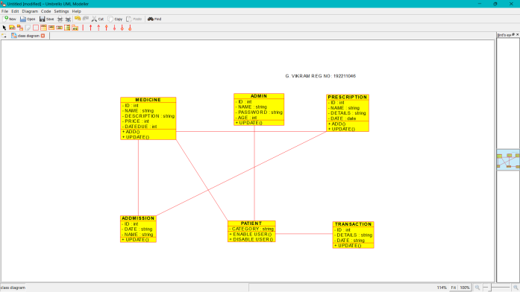

**USECASE**

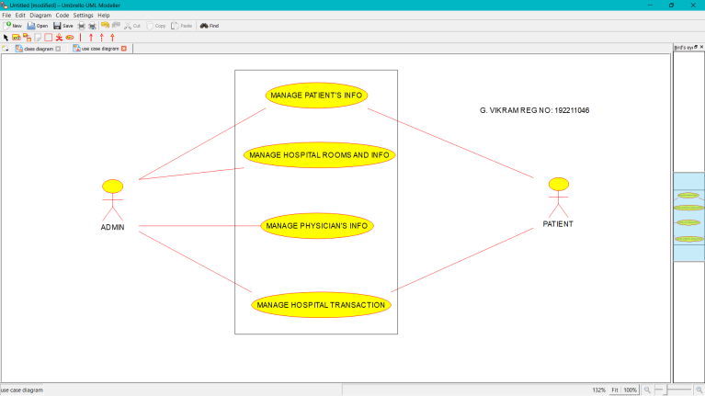

**SEQUENCE**

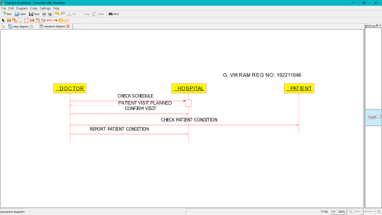

22. Develop a system using UML for Online Insurance Processing System. The admin can create a category and sub-category, under which a new policy can be added. The user can view and buy the required policies. The system is managed by the Insurance Management System.

**ACTIVITY DIAGRAM DEPLOYMENT**

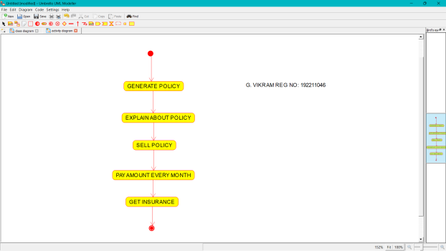 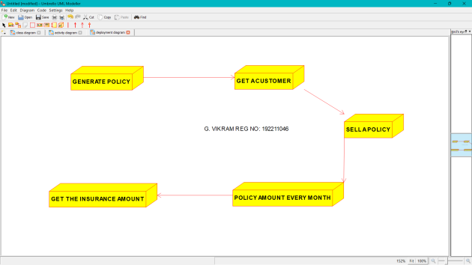

**PACKAGE**

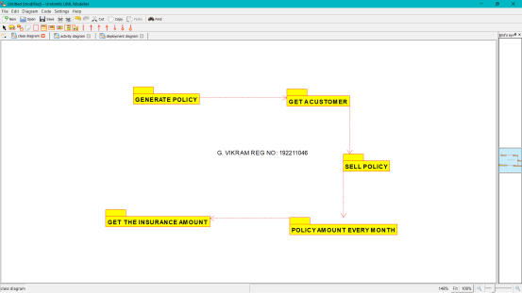

23. Develop a system using UML for Online Shopping System. This system should represent the shopping system as well as its primary users, and roles. The logs of the transactions should be carried out for the shopping. The cart should be maintained before the purchase transaction.

**ACTIVITY** **COMPONENT**

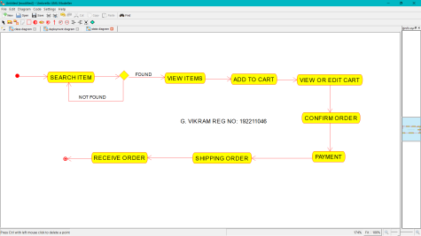 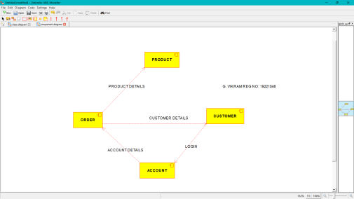

**USE CASE DIAGRAM**

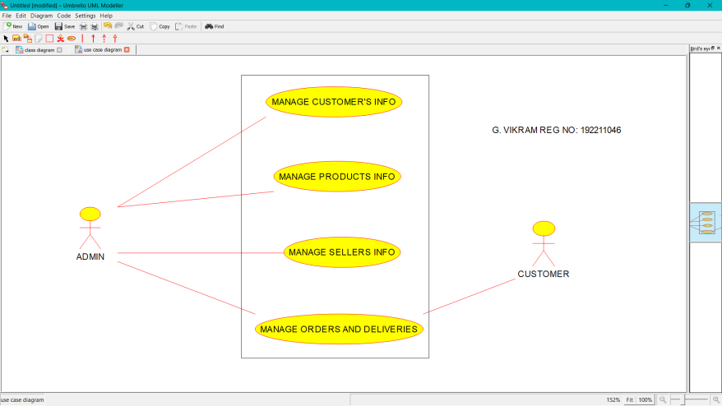

24. Develop a system using UML for Online Stock Market System. This System facilitates its users the trade (i.e. buying and selling) stocks online. It allows clients to keep track of and execute their transactions of the different stocks in their portfolios. The central system should keep track of all the users, who interact with the system.

**SEQUENCE**

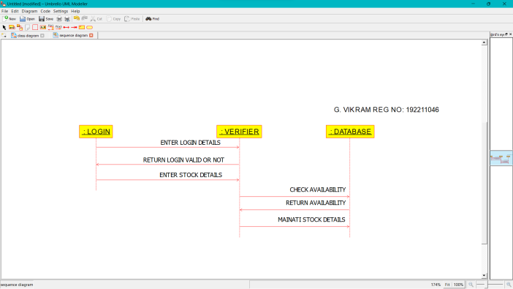

**CLASS**

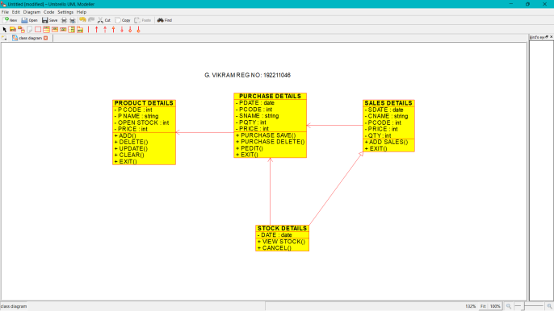

**USECASE**

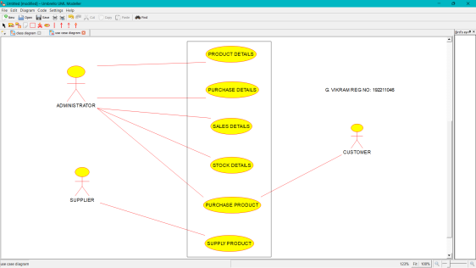

25. Develop a system using UML for Online Voting System. Registration of the new citizen and update can be done in the system. The process of initiating the polling. The voting was done from the citizen’s end and the result publishing should be maintained by the admin.

**COMPONENT**

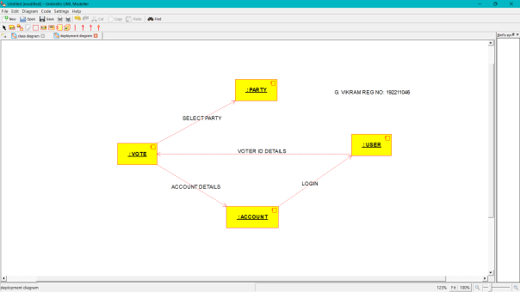

**ACTIVITY**

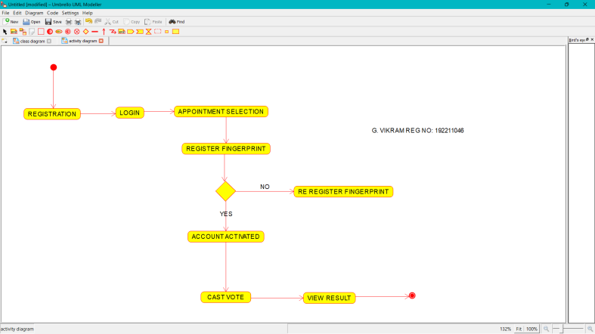

**SEQUENCE**

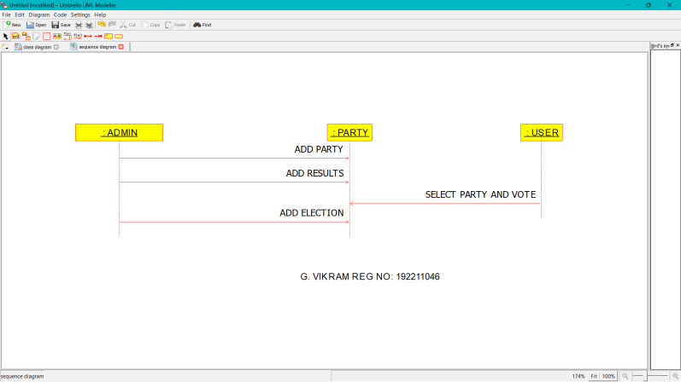

26. Develop a system using UML for Jewellery Shop Management System. The admin can add new customer detail and update the existing customer’s detail. Whenever a customer made a purchase, it should reflect in the bill details as well as in the customer details. Also, the system should update the stock remained the shop.

**CLASS**

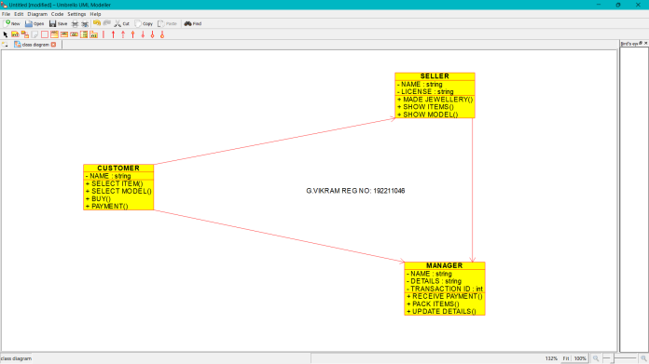

**DEPLOYMENT**

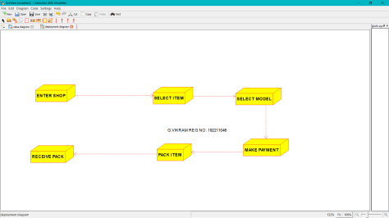

**USECASE**

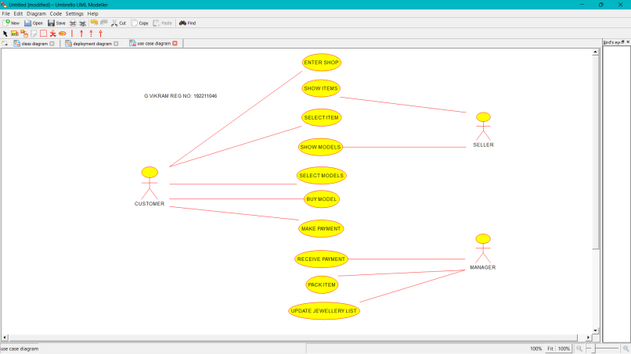

27. Develop a system using UML for Supermarket Management System. The system should maintain the stock detail, employee detail, and customer details. The system should intimate the product with low stock and nearing the expiry date. The loyalty feature of the customers should be maintained. The offers to the customers should be based on their loyalty features.

**USE CASE DIAGRAM**

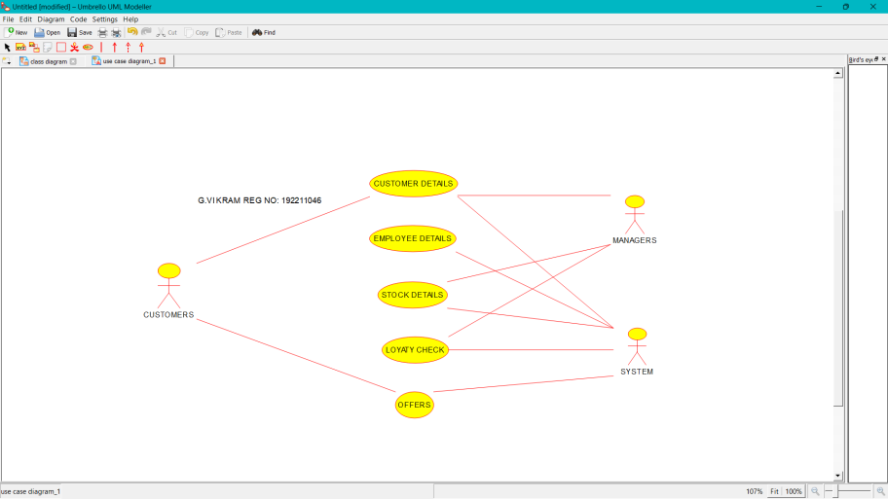

**CLASS**

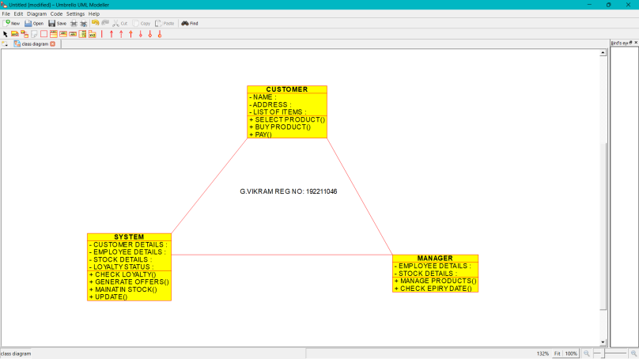

**COMPONENT**

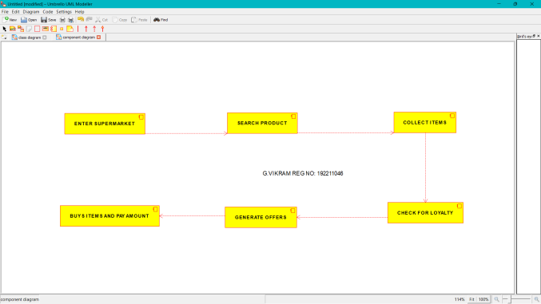

28. Develop a system using UML for Airplane Reservation System. The customer can search for flights for a given data and source/destination airport and reserve the required seats, the system should handle the payment. The customer can view flight schedules and cancel their reservation(s) if needed. Admin can add new aircraft, flights, and flight schedules. Admin can cancel any prescheduled flight and a notification should be sent to all stakeholders.

**ACTIVITY**

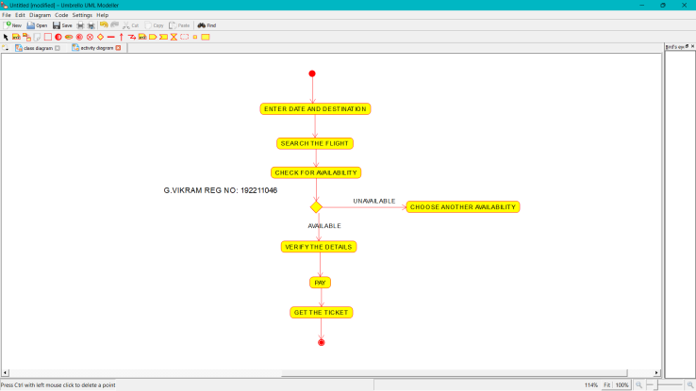

**COMPONENT**

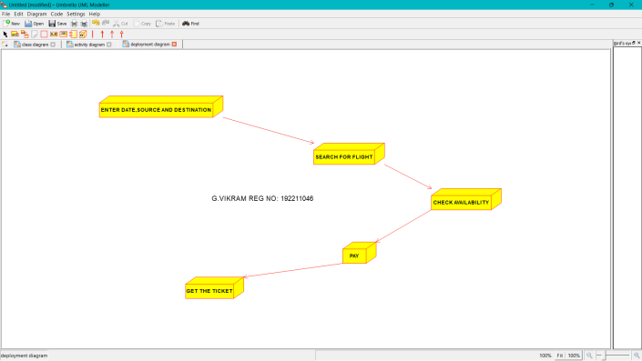

**PACKAGE**

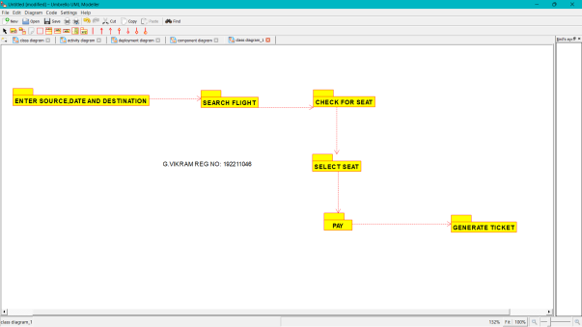

29. Develop a system using UML for the Bus ticket Reservation System. The customer can create a login and the details are stored by the system. The customer can view the bus and seat availability from source to destination on a given date and time. The customer can book tickets and view the status of the bus. The customer can cancel the ticket and a refund will be decided based on the time remaining before the departure of the bus.

**ACTIVITY**

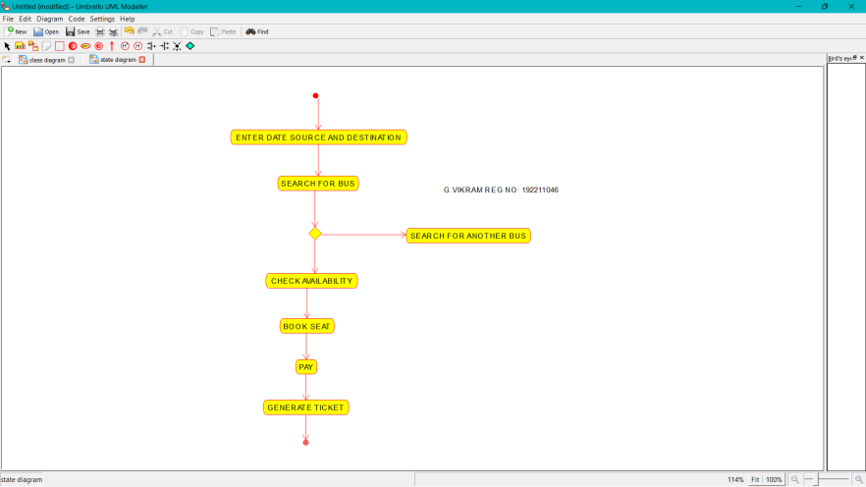

**COMPONENT**

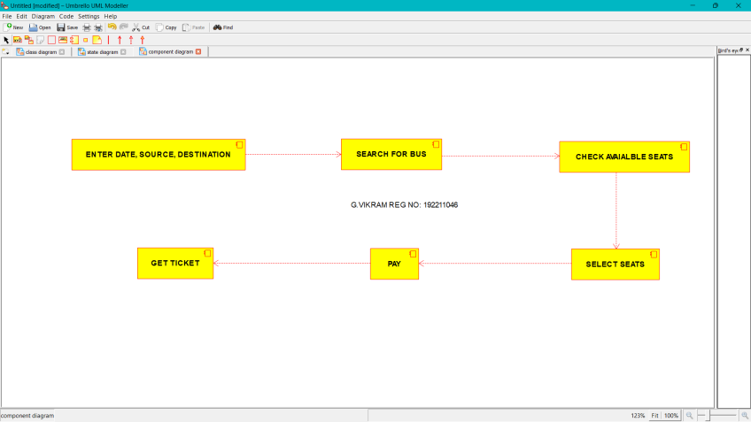

**SEQUENCE DIAGRAM**

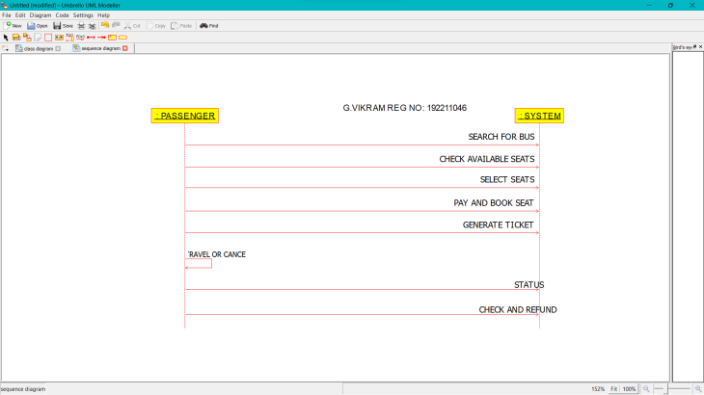

30. Develop a system using UML for the Train ticket Reservation System. The customer can create a login and the details are stored by the system. The customer can view the train and seat availability from source to destination on a given date and time. The customer can book tickets and view the status of the train. The customer can cancel the ticket and a refund will be decided based on the time remaining before the departure of the bus.

STATECHART

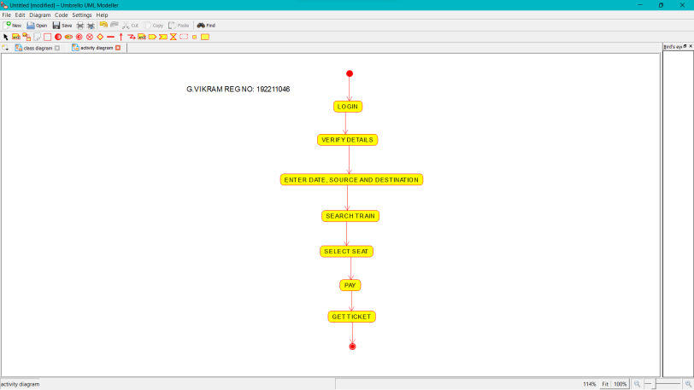

**CLASS**

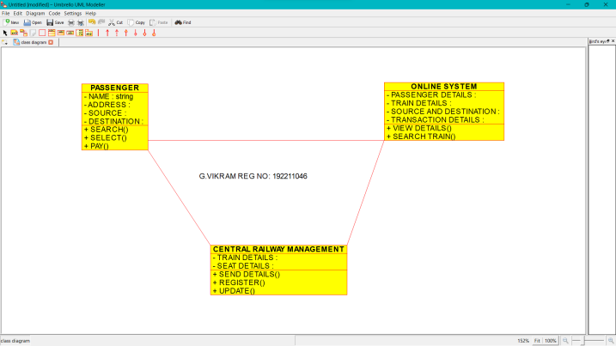

**USECASE**

